MapReduce

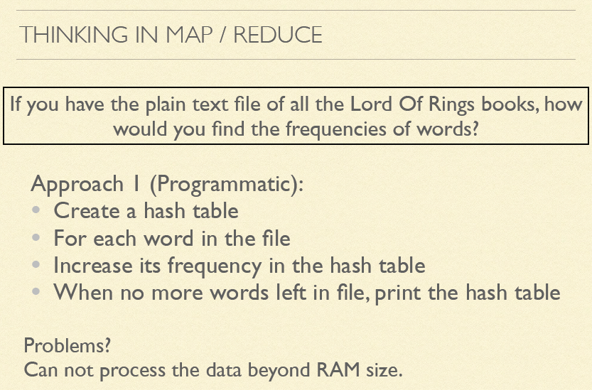

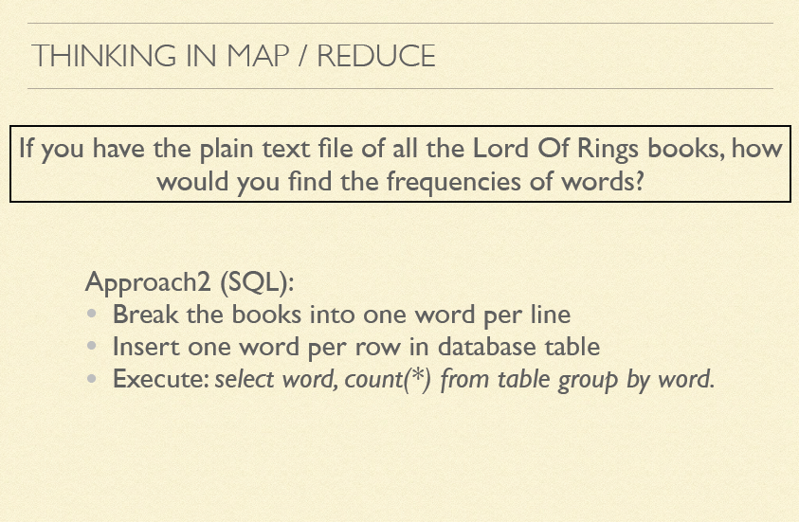

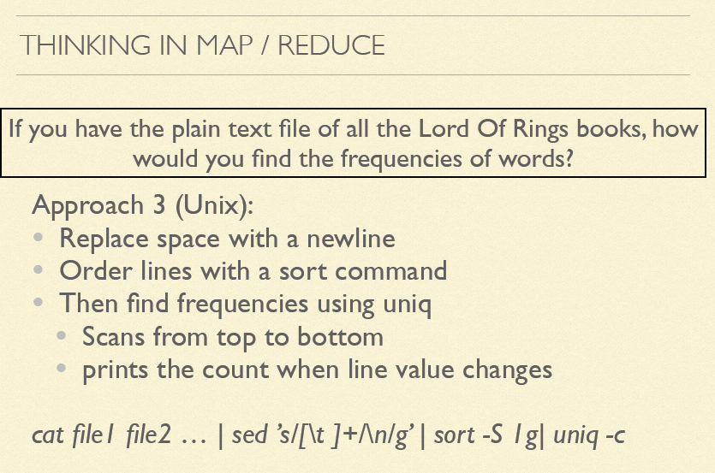

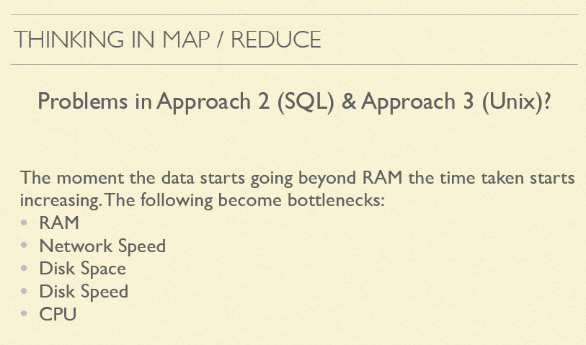

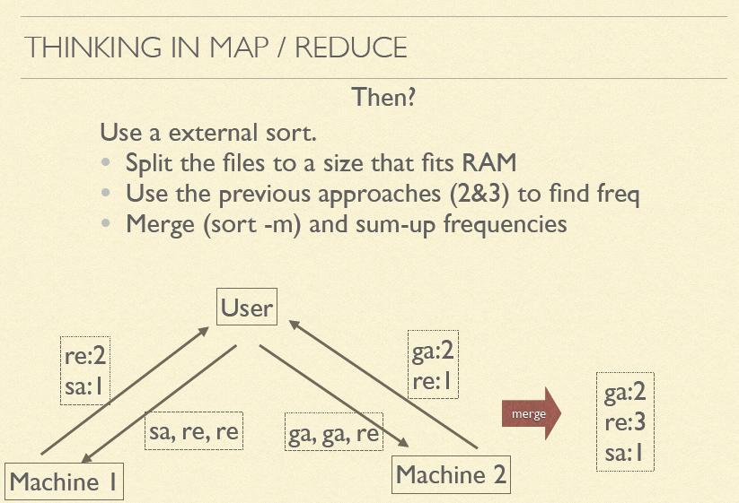

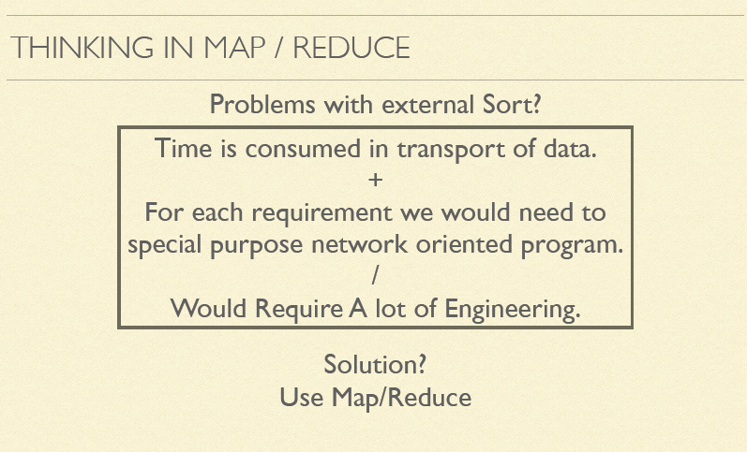

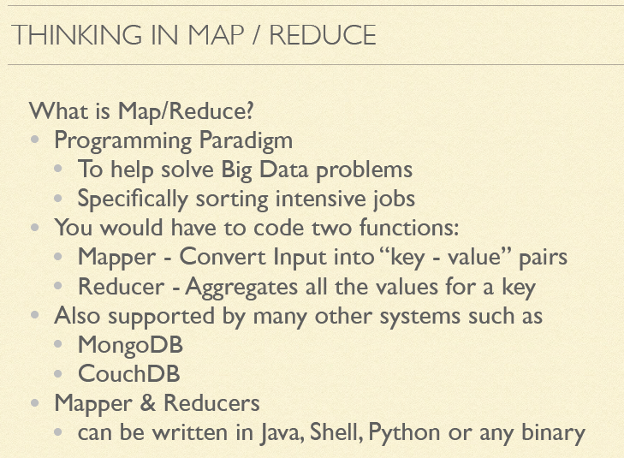

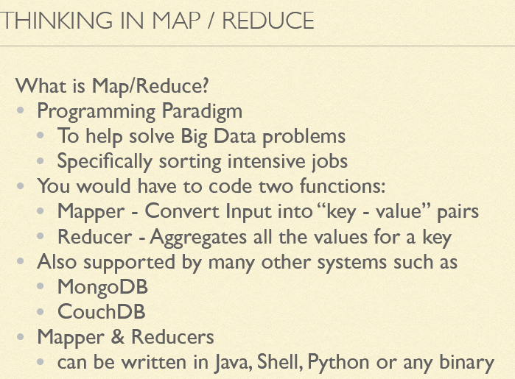

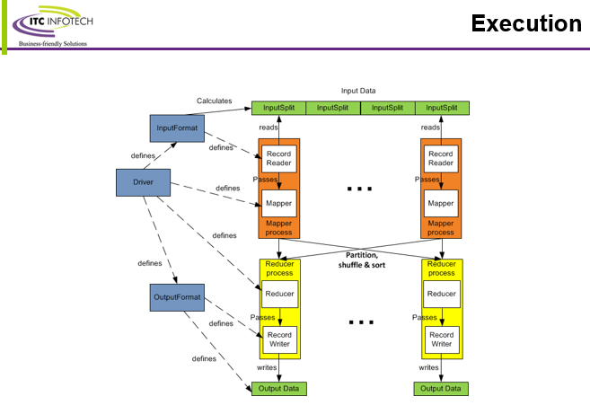

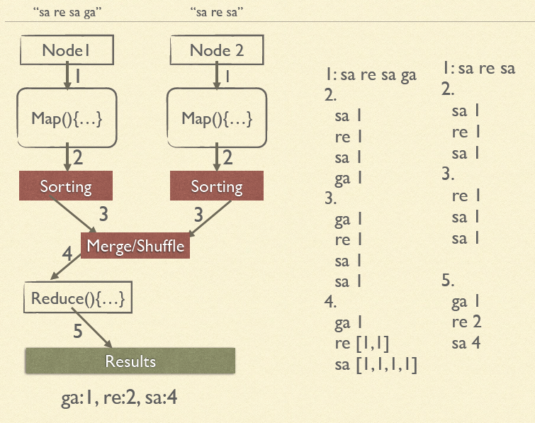

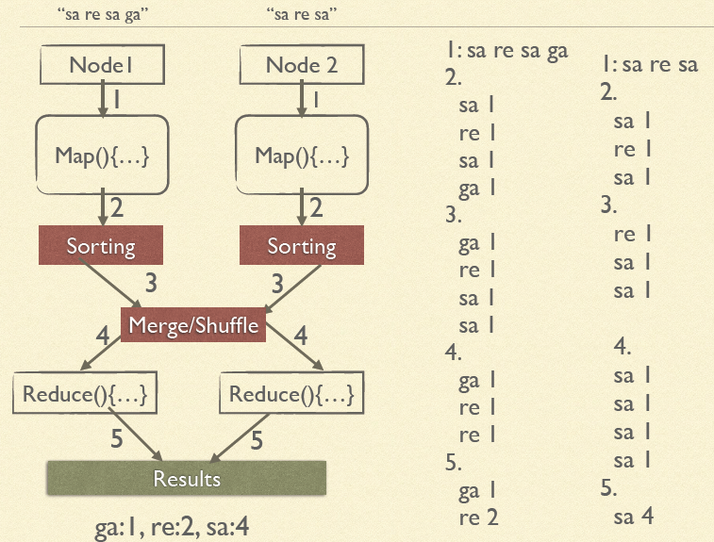



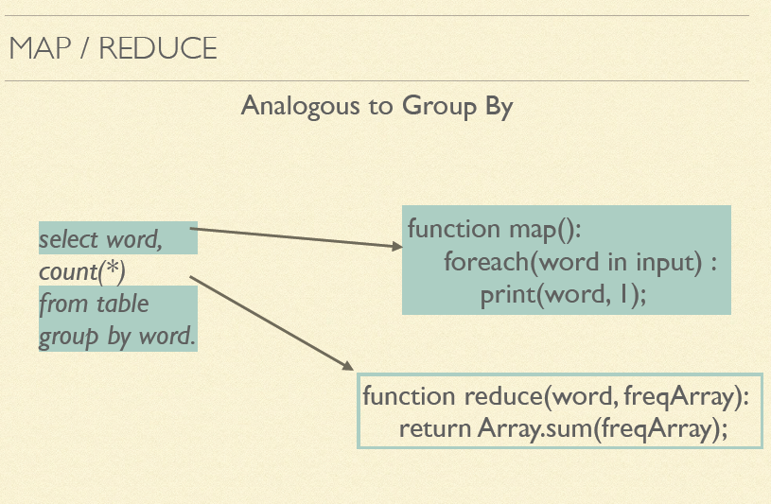

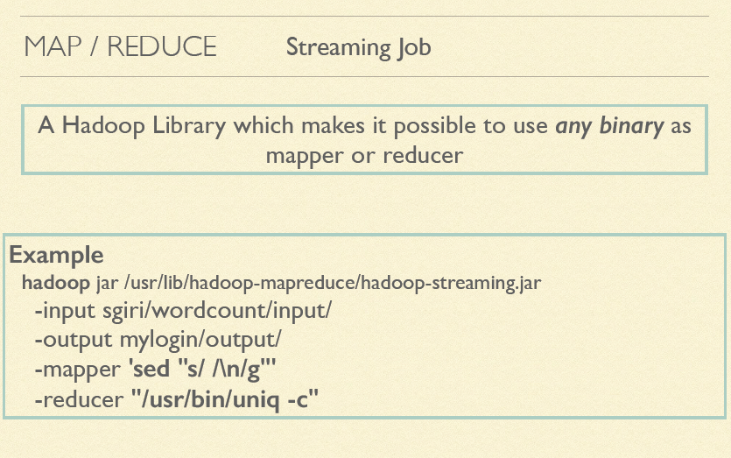

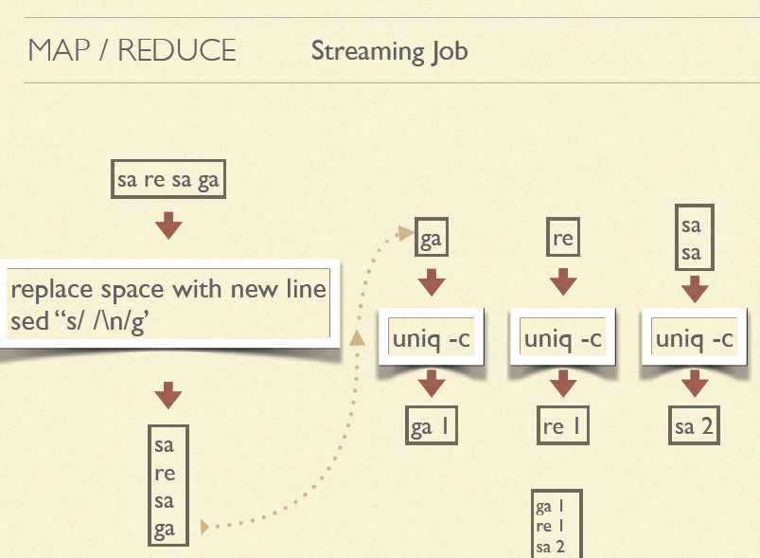

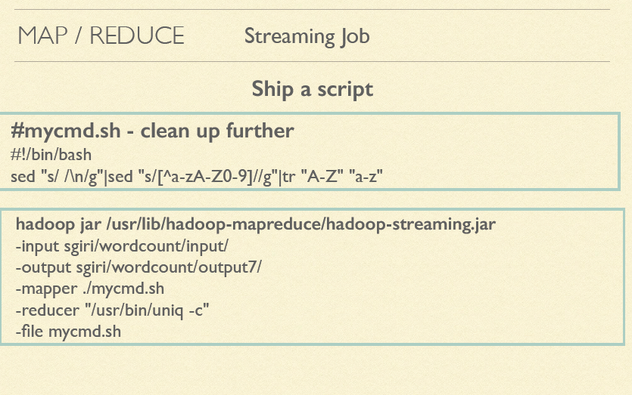

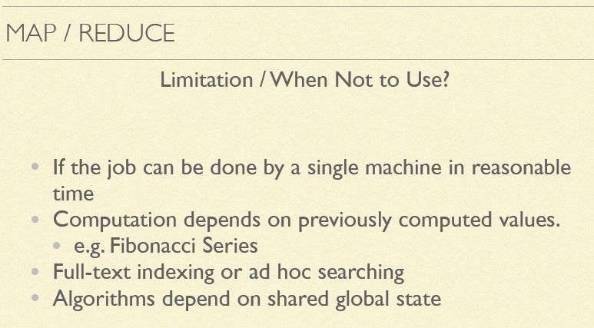

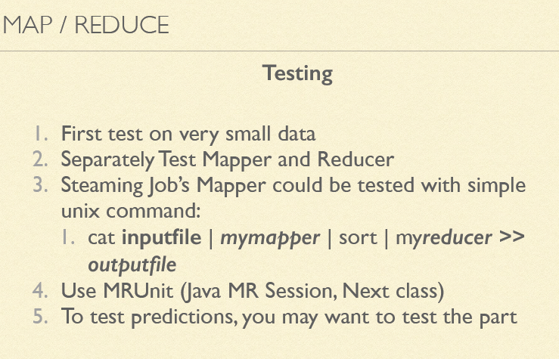

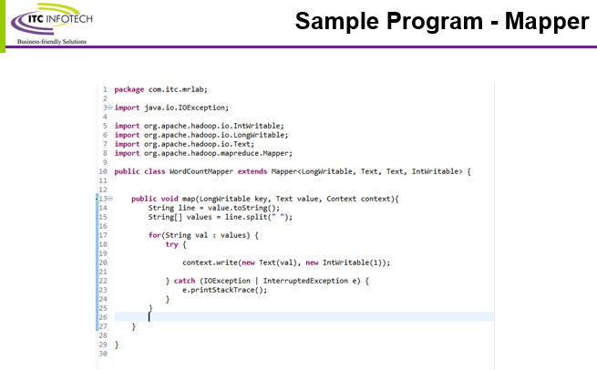

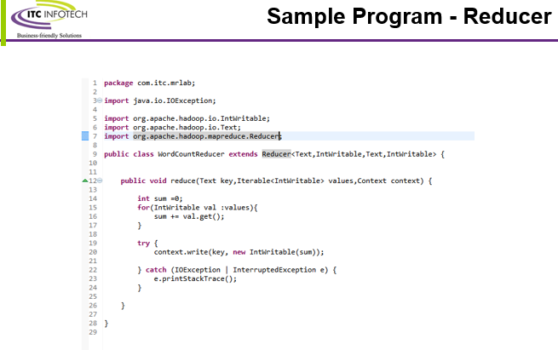

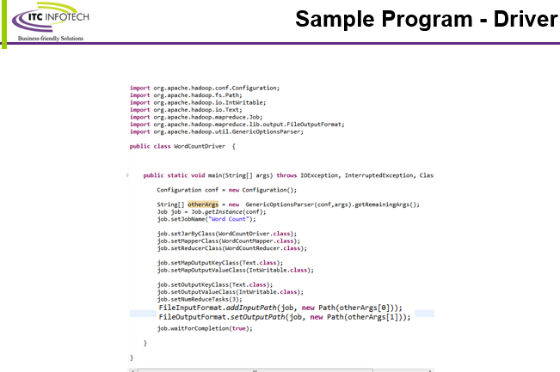

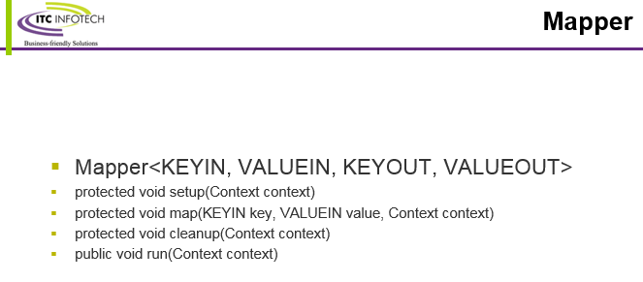

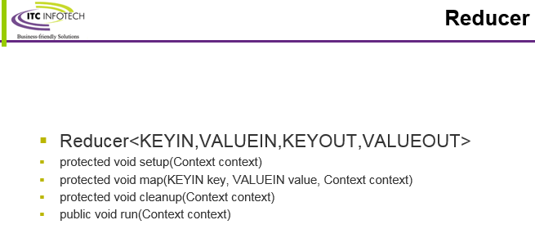

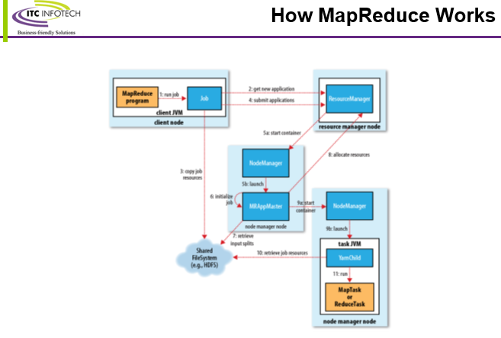

**Input Split**

* An input split is a chunk of the input that is processed by a single map.
* Split doesn’t contain the input data; it is just a reference to the data. The storage locations are used by the MapReduce system to place map tasks as close to the split’s data as possible, and the size is used to order the splits so that the largest get processed first, in an attempt to minimize the job runtime.
* An InputFormat is responsible for creating the input splits and dividing them into records
* By default the split size is equivalent to block size.

**Input Format**

FileInputFormat is the base class for all implementations of InputFormat that use files as their data source

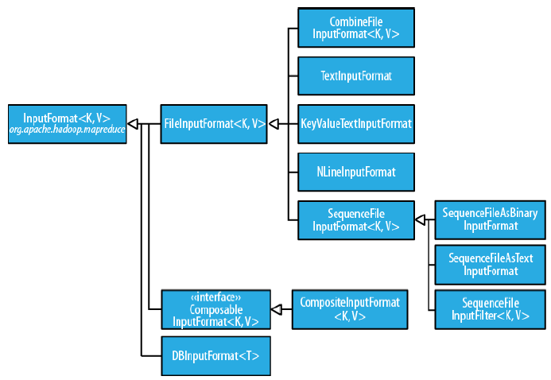

**CombineFileInputFormat**, which was designed to work well with small files. Where FileInputFormat creates a split per file,CombineFileInputFormat packs many files into each split so that each mapper has more to process.

**SequenceFile**

One technique for avoiding the many small files case is to merge small files

into larger files by using a SequenceFile. With this approach, the keys can act as filenames

(or a constant such as NullWritable, if not needed) and the values as file contents

**Processing a whole file as a record**

A related requirement that sometimes crops up is for mappers to have access to the full

contents of a file. Not splitting the file gets you part of the way there, but you also need

to have a RecordReader that delivers the file contents as the value of the record. The

listing for WholeFileInputFormat in Example 7-2 shows a way of doing this.

Example. An InputFormat for reading a whole file as a record

==============================================================

public class WholeFileInputFormat

extends FileInputFormat<NullWritable, BytesWritable> {

@Override

protected boolean isSplitable(JobContext context, Path file) {

return false;

}

@Override

public RecordReader<NullWritable, BytesWritable> createRecordReader(

InputSplit split, TaskAttemptContext context) throws IOException,

InterruptedException {

WholeFileRecordReader reader = new WholeFileRecordReader();

reader.initialize(split, context);

return reader;

}

}

Example. The RecordReader used by WholeFileInputFormat for reading a whole file as a record

class WholeFileRecordReader extends RecordReader<NullWritable, BytesWritable> {

private FileSplit fileSplit;

private Configuration conf;

private BytesWritable value = new BytesWritable();

private boolean processed = false;

@Override

public void initialize(InputSplit split, TaskAttemptContext context)

throws IOException, InterruptedException {

this.fileSplit = (FileSplit) split;

this.conf = context.getConfiguration();

}

@Override

public boolean nextKeyValue() throws IOException, InterruptedException {

if (!processed) {

byte[] contents = new byte[(int) fileSplit.getLength()];

Path file = fileSplit.getPath();

FileSystem fs = file.getFileSystem(conf);

FSDataInputStream in = null;

try {

in = fs.open(file);

IOUtils.readFully(in, contents, 0, contents.length);

value.set(contents, 0, contents.length);

} finally {

IOUtils.closeStream(in);

}

processed = true;

return true;

}

return false;

}

@Override

public NullWritable getCurrentKey() throws IOException, InterruptedException {

return NullWritable.get();

}

@Override

public BytesWritable getCurrentValue() throws IOException,

InterruptedException {

return value;

}

@Override

public float getProgress() throws IOException {

return processed ? 1.0f : 0.0f;

}

@Override

public void close() throws IOException {

// do nothing

}

}

Text Input

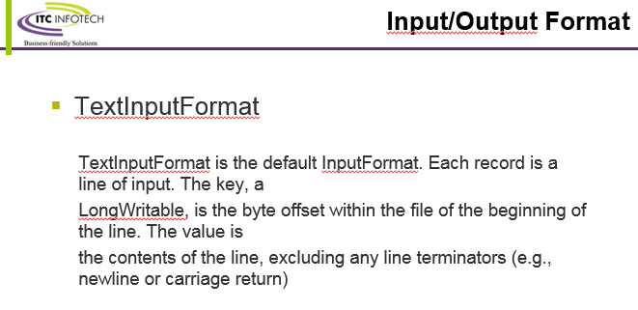

**TextInputFormat**

TextInputFormat is the default InputFormat. Each record is a line of input. The key, a

LongWritable, is the byte offset within the file of the beginning of the line. The value is

the contents of the line,

**KeyValueTextInputFormat**

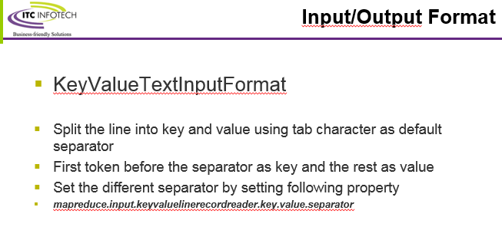

This is used for processing text files with key and value data. For ex: if the key and value are separated by default tab then using the KeyValueTextInputFormat generates the key in the text file as the output record key and the text value as the out put record value.

**NLineInputFormat**

If you want your mappers to receive a fixed number of lines of input, then NLineInputFormat is the InputFormat to use. Like TextInputFormat, the keys are the byte offsets within the file and the values are the lines themselves.

**XML**

Hadoop comes with a class for this purpose called StreamXmlRecordReader (which is in

the org.apache.hadoop.streaming package, although it can be used outside of Streaming).

You can use it by setting your input format to StreamInputFormat and setting the

stream.recordreader.class property to org.apache.hadoop.streaming.StreamXml

RecordReader. The reader is configured by setting job configuration properties to tell it

the patterns for the start and end tags.

**Binary Input**

SequenceFileInputFormat

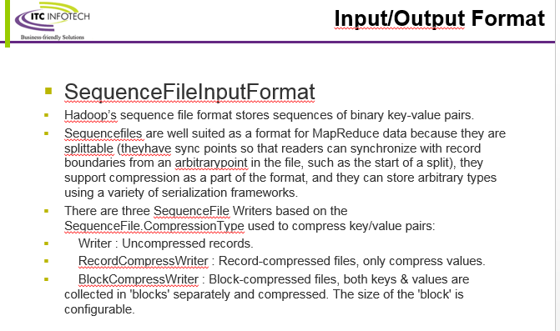

Hadoop’s sequence file format stores sequences of binary key-value pairs. Sequence

files are well suited as a format for MapReduce data because they are splittable (they

have sync points so that readers can synchronize with record boundaries from an arbitrary

point in the file, such as the start of a split), they support compression as a part

of the format, and they can store arbitrary types using a variety of serialization frameworks

SequenceFileAsTextInputFormat

SequenceFileAsTextInputFormat is a variant of SequenceFileInputFormat that converts

the sequence file’s keys and values to Text objects.

SequenceFileAsBinaryInputFormat

SequenceFileAsBinaryInputFormat is a variant of SequenceFileInputFormat that retrieves

the sequence file’s keys and values as opaque binary objects.

Multiple Inputs

Although the input to a MapReduce job may consist of multiple input files (constructed

by a combination of file globs, filters, and plain paths), all of the input is interpreted

by a single InputFormat and a single Mapper. What often happens, however, is that the

data format evolves over time, so you have to write your mapper to cope with all of

your legacy formats. Or you have data sources that provide the same type of data but

in different formats.

These cases are handled elegantly by using the MultipleInputs class, which allows you

to specify which InputFormat and Mapper to use on a per-path basis.

MultipleInputs.addInputPath(job, ncdcInputPath,

TextInputFormat.class, MaxTemperatureMapper.class);

MultipleInputs.addInputPath(job, metOfficeInputPath,

TextInputFormat.class, MetOfficeMaxTemperatureMapper.class);

Database Input (and Output)

DBInputFormat is an input format for reading data from a relational database, using

JDBC.

